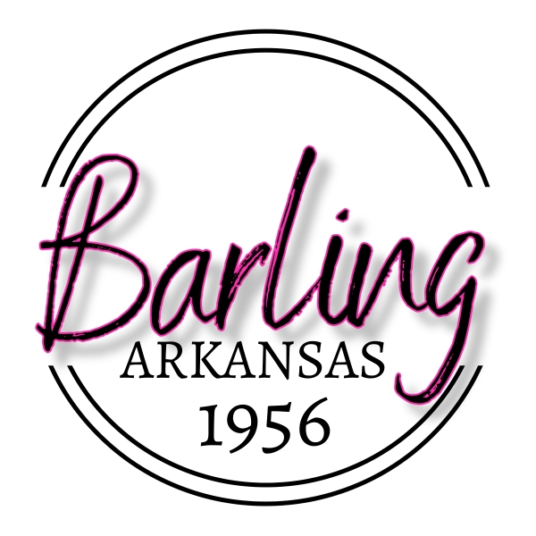
PO Box 23039 Barling, Arkansas 72923-0039
(479) 452-1550

AGENDA
BOARD OF DIRECTORS MEETING
TUESDAY MARCH 25, 2025
5:30 P.M.
CITY HALL

CALL TO ORDER
PLEDGE OF ALLEGIANCE
INVOCATION
ROLL CALL

- APPROVAL OF MINUTES OF MARCH 11, 2025

2. PUBLIC INPUT (LIMIT 2 MINUTES PER PERSON) AGENDA ITEMS ONLY

3. UNFINISHED BUSINESS

4. NEW BUSINESS

A. CONSIDERATION OF PAYMENT TO SUPERIOR AUTOMOTIVE GROUP TO PURCHASE AND PAY FOR A 2025 CHEVROLET TAHOE FOR FIRE CHIEF

B. CONSIDERATION OF PAYMENT TO DATA TESTING INC FOR WATER PERMIT

5. DEPARTMENT HEAD REPORTS

6. CITY ADMINISTRATOR REPORT

7. ANNOUNCEMENTS

8. PUBLIC INPUT (LIMIT 2 MINUTES PER PERSON) NON-AGENDA ITEMS

9. ADJOURN

