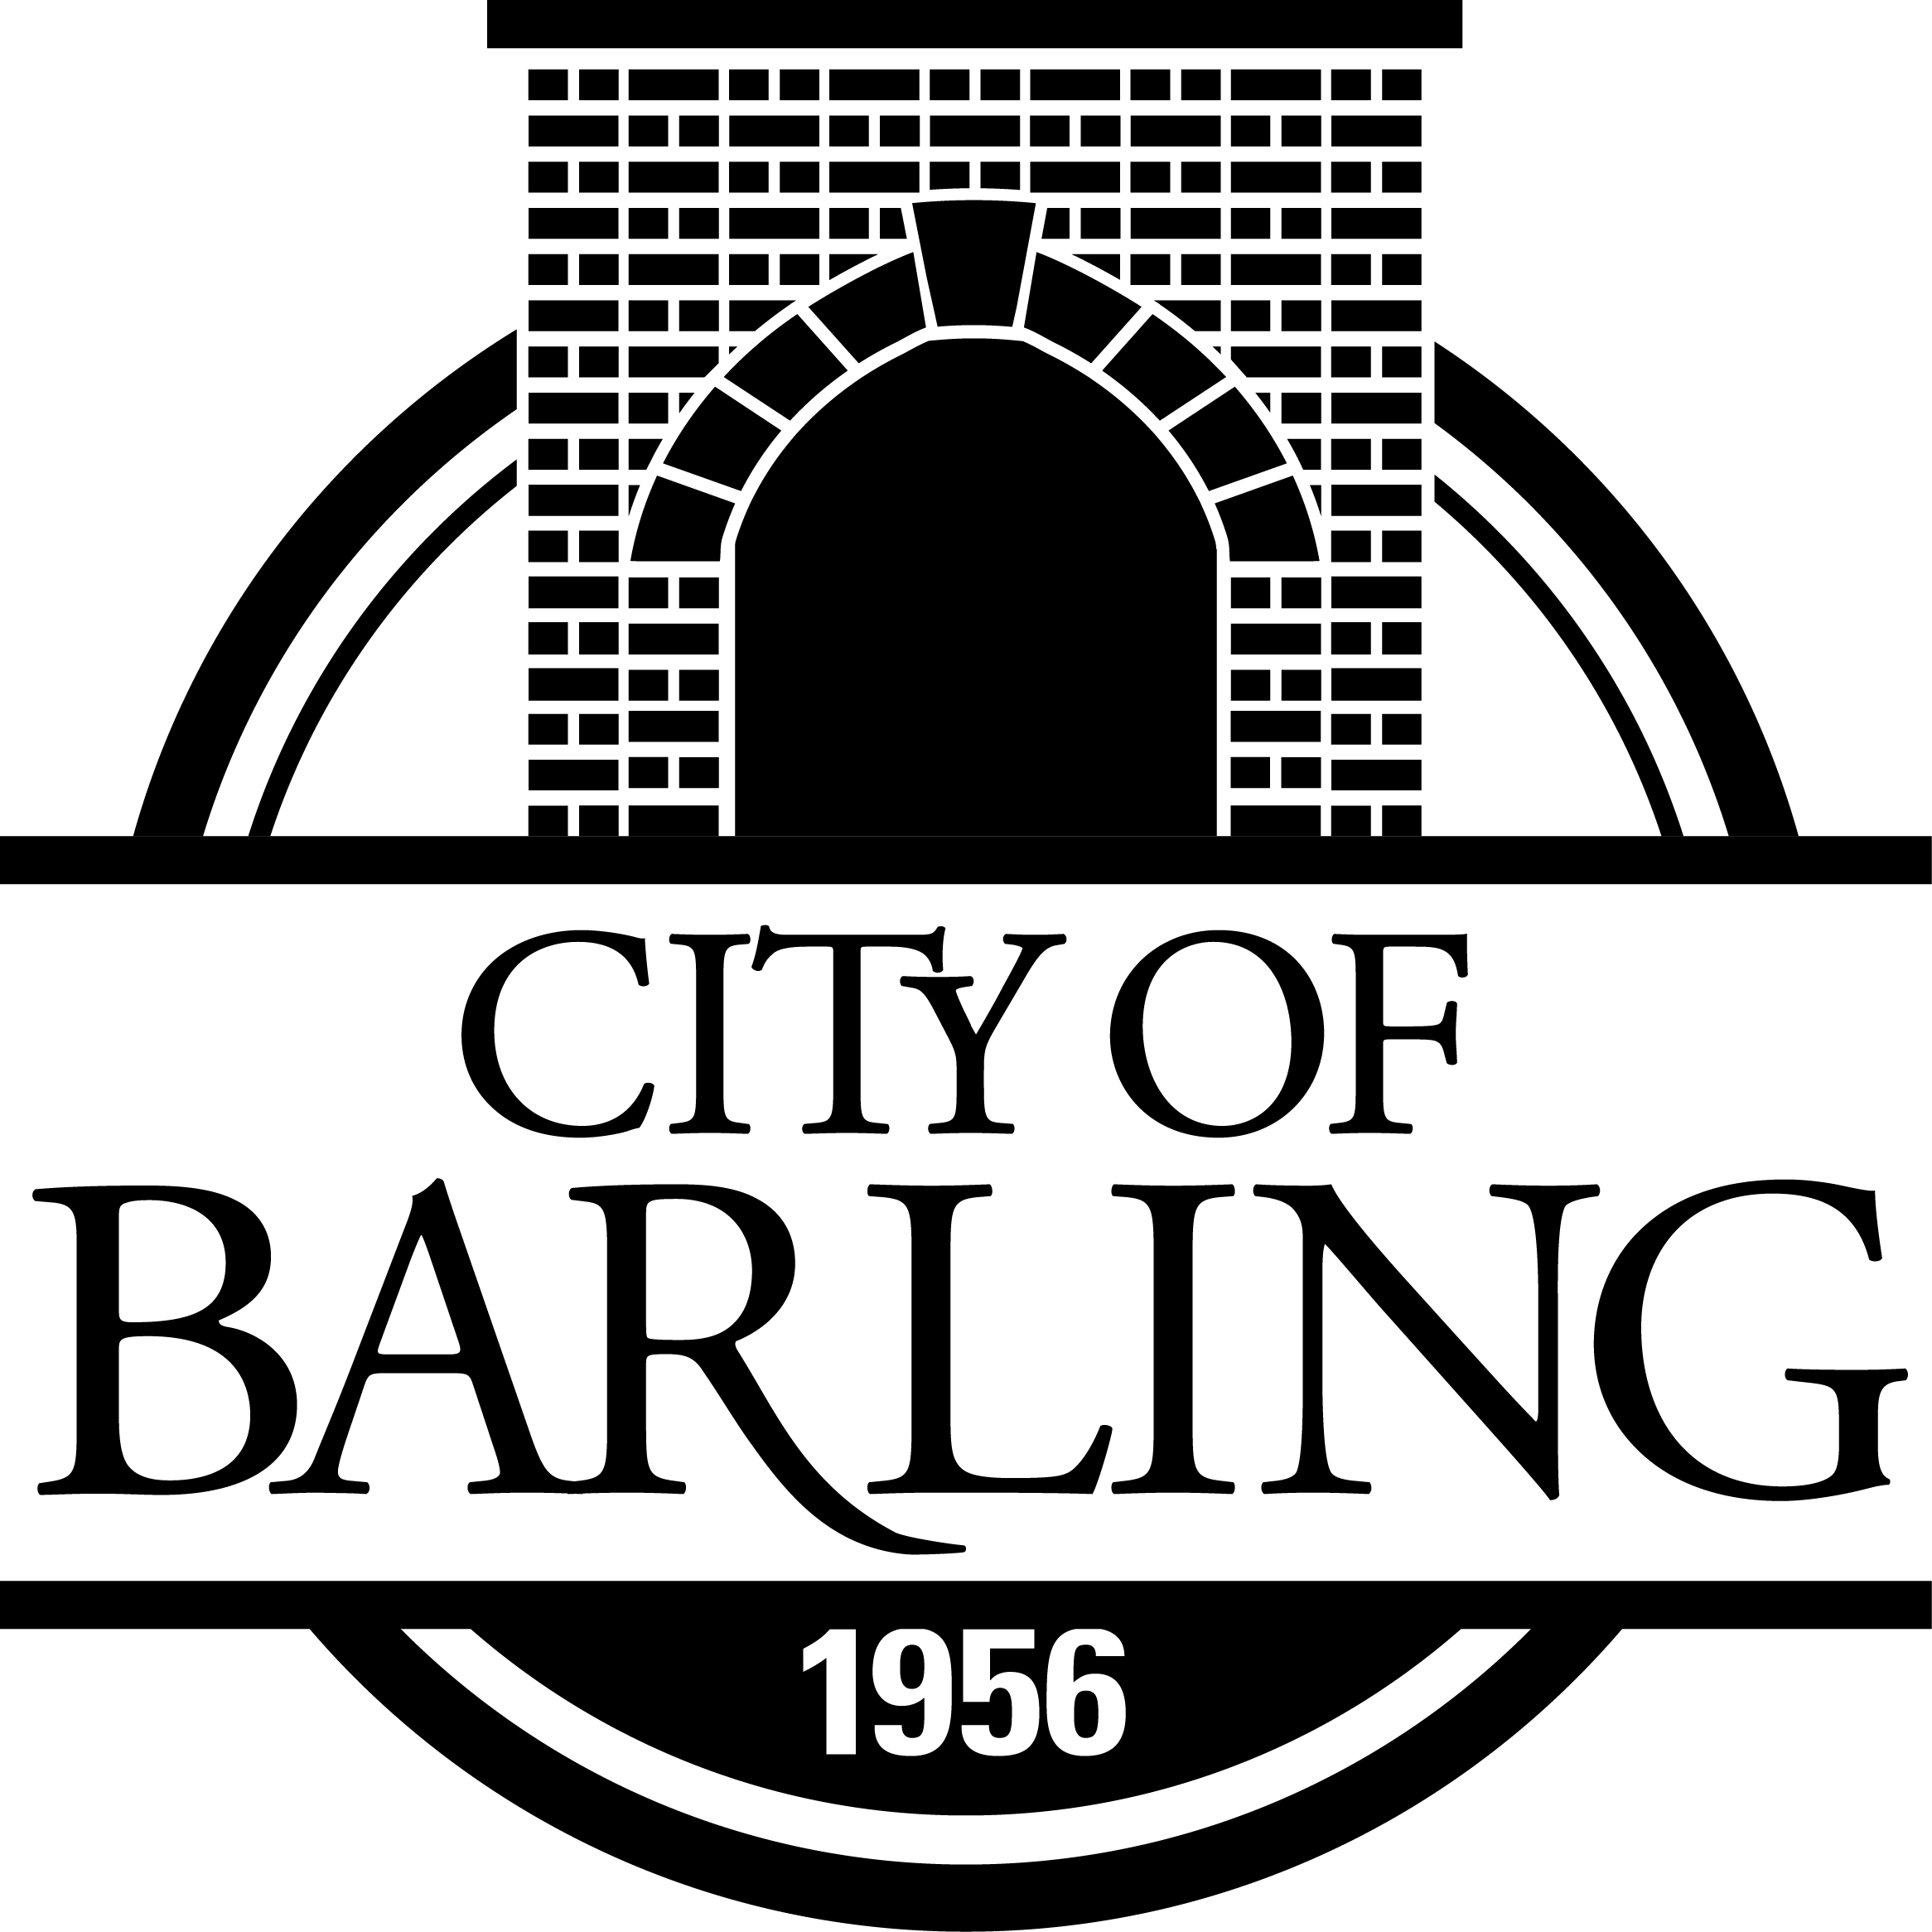
PO Box 23039 Barling, Arkansas 72923-0039
(479) 452-1550

AGENDA

MONDAY, JANUARY 6, 2025
PLANNING COMMISSION
5:30 P.M. AT CITY HALL

CALL TO ORDER
ROLL CALL

APPROVAL OF MINUTES OF OCTOBER 7, 2024

AGENDA ITEMS:

- OLD BUSINESS

- NEW BUSINESS

A. CONSIDERATION OF REQUEST FROM MGC DEVELOPMENT FOR A VARIANCE REGARDING THE USE OF BACKFLOW PREVENTERS

B. CONSIDERATION OF PLANS FROM NORRIS GROUP FOR A 3.85 ACRE DEVELOPMENT EXTENSION OF SPRINGHILL ESTATES

C. CONSIDERATION OF PLANS FOR THE ASHTON PLACE CLUBHOUSE

REPORTS

PUBLIC COMMENT (AGENDA ITEMS ONLY, 2 minutes maximum)

ADJOURN

