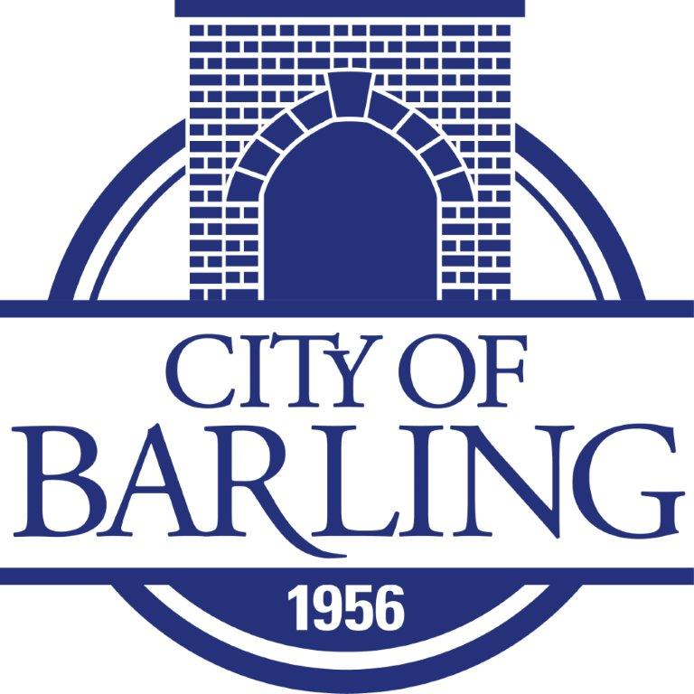
307 Fort Street, PO Box 23039, Barling, Ar. 72923
479-452-1550
________________________

DOOR-TO-DOOR SALES

SOLICITOR’S LICENSE

SOLICITATION HOURS: 08.00 A.M. TO 7:00 P.M.
Permits are valid for a three-day period. Cost of permit is $15.00.

APPLICATION DATE:
SALES DATES: ____________, ____________, _____________

BUSINESS NAME:
TYPE OF GOODS TO BE SOLD:

APPLICANT NAME:
APPLICANT DATE OF BIRTH:
APPLICANT HOME ADDRESS:
APPLICANT PHONE NUMBER:

APPLICANT IDENTIFICATION TYPE:
IDENTIFICATION NUMBER:
ISSUING ENTITY:
EXPIRATION DATE:

VEHICLE MAKE:
VEHICLE MODEL:
VEHICLE COLOR:
LICENSE TAG NUMBER:

Background check completed by:

The above applicant, having complied with the requirements of the Ordinance of the City of Barling, Arkansas, is hereby granted a Door-to-Door Sales License.

________________________________________

Florene Brown, City Clerk

______________________________________
Bryan Fuller, Police Chief

THIS LICENSE MUST BE WITH THE PERSON WHO’S NAME APPEARS ON THE LICENSE AT ALL TIMES AND IS NOT TRANSFERABLE

